|  |  |
| --- | --- |
|  |  |

# Student Assessment Submission and Declaration

When submitting evidence for assessment, you must sign a declaration confirming that the work is your own.

|  |  |  |  |
| --- | --- | --- | --- |
| Student name: |  | ESL ID No |  |
| BSU ID No |  |
| Submission date: | | |  |
|  | | |  |
| Programme: |  | | |
| Module name and code: |  | | |
| Title: | COMPUTATIONAL REASONING | | |
| Assessor name: |  | | |

**Plagiarism**

Plagiarism is a form of cheating. Plagiarism must be avoided at all costs and students who break the rules, however innocently, may be penalised. It is your responsibility to ensure that you understand correct referencing practices. As a university level student, you are expected to use appropriate references throughout and keep carefully detailed notes of all your sources of materials for material you have used in your work, including any material downloaded from the Internet. Please consult the relevant unit lecturer or your course tutor if you need any further advice.

|  |  |  |  |
| --- | --- | --- | --- |
| **Student declaration**  I certify that the assignment submission is entirely my own work. I fully understand the consequences of plagiarism. I understand that making a false declaration is a form of malpractice. | | | |
| Student signature: |  | Date: |  |

COMPUTATIONAL REASONING: SET EXERCISES

# 

**Table of Contents**

Introduction 3

Review 1: Interest Rates and Student Loans 3

a. Summary of the Topic 3

i. Explanation and Mathematical Findings: 4

ii. Mathematical Findings and Formulas 4

ii. Graphical Representations 4

b. Personal Contributions 4

c. What I Learned 5

Review 2: Dealing with Percentages 5

a. Summary of the Topic 5

i. Explanation and Mathematical Findings: 5

ii. Formulas used 6

ii. Graphical Representations 6

b. Personal Contributions 6

c. What I Learned 6

2) Mathematical problem 7

3) Modelling 8

Conclusion 9

Reference List 11

# Introduction

Three major aspects of mathematical use in the real-world settings that find synthesis in this report are as follows: team-based research in mathematics, financial problem solving and mathematical modelling. The first part provides a critical analysis of two group projects, completed within the course. These reviews not only recapitulate the chosen topics but also show the mathematical conclusions, formulas used, graphical tools and the personal input. The second part covers financial issue of converting students’ income and tuition fees from Turkish Lira into British Pound, using real exchange data. It also includes annual interest to provide the total amount of loan accrued. The third and final section discusses a practical modeling activity, design of a system to determine average speeds of vehicles recorded by several fixed cameras. The model applies distance time relationships and guarantees accuracy due to data synchronization. Combined, the sections indicate integrated sense of how mathematics is applied to theoretical, financial, and actual life transport cases.

# Review 1: Interest Rates and Student Loans

## a. Summary of the Topic

The “Interest rates and Student loans” project examines a number of financial situations based on interest rates, loans and investments. It explores the mathematical calculations involved in efforts to appreciate the effect of interest on loans, savings and investment in different lapses of time. The basic idea is to learn about compound interest and its consequences, first on increasing debt, and second on expanding savings.

The project addresses several real financial cases. It starts from easy interest calculations on a personal loan. It centers hence, to compound interest in savings accounts. Credit card situations are examined: interest-free periods on introduction, charges and the build-up of debt at a high Annual Equivalent Rates (AER) (Zill, 2020). The costs comparison of various purchasing methods, including, payment in advance and hire purchase, is also undertaken by the project.

Major parts of the project concern student loans, the impact of tuition fees, bursaries and interest rates on the total sum owed by a student at graduation. It also looks in details on how these salaries increases affect paying back these loans over time. Finally, the project discusses how investments in the stock market can return to be both profits or losses, depending on interest rates.

### i. Explanation and Mathematical Findings:

This project takes a detailed look at the way interest rates rule the expansion of savings and debt accumulation (from loans and credit cards), and ultimately student loan cost. Important mathematical findings include the contrast between the impact of simple and compound interest over time, rapidly compounding high AER credit card debt, and the long term economic effects of student loan interest rates and repayment schedules bound to income.

### ii. Mathematical Findings and Formulas

There are several important formulas in the project, which are used to create the solution of the problem.

**Simple Interest:** Interest = (Principal) (Rate) (Time)

This is to be used for calculating the interest in Steve’s loan.

**Compound Interest:** A = P (1 + r/n)(nt)

A = future value, P = principal, r = annual interest rate, n = number of times that interest is compounded per year; t = time in years. This formula applies for savings account and credit card debts.

**Percentage Change:** ((New Value- Old Value) / Old Value ) x 100%.

This formula finds an implicit application in computation of salary computations, and depreciation/appreciation of assets.

### ii. Graphical Representations

The graphical representations are not entirely featured in the document. There were, however, calculations performed that could be demonstrated graphically. For example:

* An increase of savings over period of time could be displayed with an exponential curve (compound interest).
* The equilibrium of a loan may be illustrated as a line which decreases (when payments occur) or as a speeding curve (in case interest increases, and is higher than the payments made).

## b. Personal Contributions

My major contribution to this project would be in organising the problems logically and the appropriate formulas being used in them. I would concentrate on confirming the compound interest as they may be difficult. In addition to that, I would present visual versions of the data, for example graphs of loan balances or investments growth throughout the period.

## c. What I Learned

This project made me remember the power of compounding interest, both on the saving and the debit side. Learning how even quite small interest percentages can influence long-term financial outcomes quite strongly instilled in me a greater appreciation of such things. I also learned the need to reflect on financial products such as credit cards and hire purchase agreements to determine their actual cost. The scenarios on students’ loans brought out the financial effects of higher education on individuals and the importance of financial planning for the graduated.

# Review 2: Dealing with Percentages

## a. Summary of the Topic

The “Dealing with Percentages’ project covers the underlying mathematical ideas and the applications of percentages. It includes a variety of percentage-related issues — from straightforward computations to such more complicated cases as percentage change, depreciation, and financial planning (Hinton, 2024).

The project starts out with basic percentage calculations such as finding percentage of a given number and turning fractions and decimals to percentages. It then moves on to percentage increase and decrease issues that are then applied to scenarios such as car value appreciation, profit projections and price fluctuations.

The project additionally looks at real life financial applications of percentages. These include computing an original price of a commodity when an allowance is granted, computing percentage increment of salary, and analyzing mortgage affordability. Moreover, it analyzes depreciation in particular, in the scope of vehicle devaluation over time and increases in wage. Finally, the current project entails problems concerning calculation of loan repayments as a percentage of income and calculation of percentage composition of stock in a store.

### i. Explanation and Mathematical Findings:

This project also covers percentages of application issues comprehensively in real life scenarios. It is a mathematical explanation of how to compute percentage increases and decreases, how to obtain the original prices after discount, how to solve depreciation and appreciation as well as understanding of percentage composition. This versatility of percentages as a means for representing proportions, changes and financial calculations in various scenarios is one of the main findings of this work.

### ii. Formulas used

The project is based upon the following central percentage formulas:

**Percentage of a Number:** (Percentage / 100) x Number

**Converting Fraction to Percentage:** (Part / Whole) x 100%

**Percentage Change:** ((New Value – Old Value)/ Old Value ) * 100%

**Depreciation:** n Years value = initial value x (1 – Depreciation rate)n

**Appreciation:** n years value = Initial Value * (1+Appreciation Rate)n

### ii. Graphical Representations

* Although the document is related to calculations the ideas could be visualized.
* Pie charts may portray the stock percentage for every category.
* Line graphs could be used in presenting the decline of value of a van in the span of time.
* The bar chart could be used to compare old and new salary.

## b. Personal Contributions

In this project, my task would be to make percentage formulas applied properly to different situations. I would concentrate on the problems with percentage change and depreciation because they need to be done with great attention to detail. I will also design visual aids to show the data, which will make understanding of how percentage increases and decreases affect things simple.

## c. What I Learned

This project developed my ability to apply percentage calculations in live situations and it came about because I needed to practice what I learnt. In learning, I now have the understanding of how percentages are employed in finance for example to compute discounts, interest and depreciation. I also came to understand the reason why it is important to have an ability to calculate percentage change accurately, which is of the greatest importance for trend analysis and decision-making. The project reiterated the flexibility of percentage as an illustrative means for describing shares and alternations in quantities.

# 2) Mathematical problem

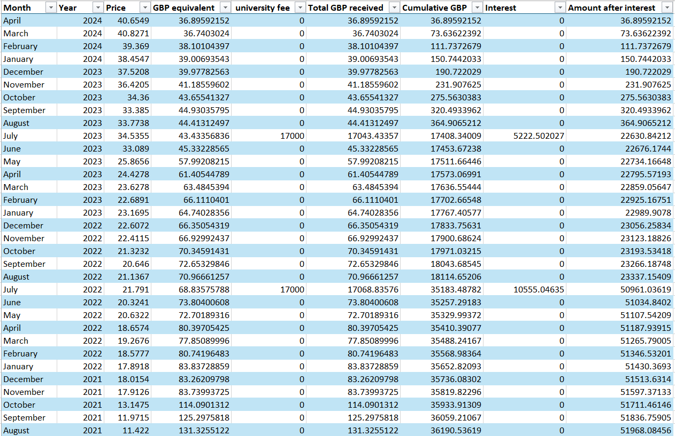

**Figure 1: Calculation of student amounts received**

(Source: Made by self)

To address this we first convert the student’s monthly Turkish Lira income to GBP using the supplied exchange rates. For each of the months, we divide 1500 TRY fixed income by the corresponding TRY to GBP exchange rate in the Excel sheet. This gives GBP equivalent one earns per month. We then allow for the 17000 GBP annual university fee that is paid in July of each year. Added to this is the GBP value of the student’s income during the month of July.



**Figure 2: Calculation of Student Loan and Interest**

(Source: Made by self)

Then we work out cumulative GBP funds received by the student during the period included in the data. From the first month, we collect a running balance for the GBP income, and the annual fee. We apply the 30% annual interest rate applied to the running cumulative balance of GBP, after the receipt of the university fee, at the end of July in each year. This interest calculation is calculated on the basis of the accrued amount as at the corresponding year to date.

https://lh7-rt.googleusercontent.com/docsz/AD_4nXcJReIwM5UVRnLZXFPC3wcc7llBdu0l22OQGQR0nApiNqGGE3uQu9wXETkYY1ZNL2gkVx5htWsOA0l13nnFRa1IPc0MRwwYoQSU1yRToCdxHw99Fcep2oVLUlywqjDztxv6jMbSeQ?key=uOiy9BDnHpkM8Zb80gN1VQ

**Figure 3: Total Outstanding loan amount**

(Source: Made by self)

The total sum of student loan in GBP will be determined by the cumulative GBP total once all monthly income converted to GBP, annual fees and yearly interest applied.

# 3) Modelling

An average speed camera system design entails calculating time taken by an object to move from one point known to the other and then filling the distance over by the time taken. Assuming that first camera is at x1 and last camera is at xn, let us assume the position of the cameras along the roads as xi for every camera. The area distance D between such two points is

D=|xn​−xn​|.

The total duration traversed for the car to travel this stretch is Δt=tn​−t1​, when a car enters the first camera at time t1​ and last camera at time tn​. Then, using the basic formula, vavg​ of the car over this stretch of the road is found.

vavg=DΔt​=|xn-x1|tn-t1

The system would timestamp each of the vehicles passing each camera. When the entry and exit timestamps for when a vehicle passes the initial and final cameras, recording the average speed check zone is established, the system can calculate the average speed using the formula above. The intermediate cameras will act as checks or even for segmenting calculation of the average speed if required for further complex monitoring.

Average speed camera systems maths implementation goes beyond simple distance/time formula. In reality, systems have to compensate for errors in both timestamping and camera calibration, which commonly uses statistical procedures as outliers elimination techniques and to validate data. In addition, high technology systems rely on algorithms to track individual vehicles in front of several cameras, even in heavy traffic, and sophisticated work with images and pattern recognition is needed. For accuracy critical testing and calibration procedures are necessary that requires comparison of the system’s measurements to independent speed measurements. The mathematical model will also consider such incidentals as road gradient or type of vehicle in fine tuning speeds though this is less common in standard systems.

# Conclusion

This report has taken a wide range of applications in mathematics from joint research to real world problem solving to modelling. In reviewing group presentations, I had been thinking about mathematical communication, teamwork and analysis. The financial loan problem demonstrated how curriculum currency is converted and how interest was calculated to apply workplace finance. Lastly, the modelling task revealed the way in which mathematical formulas can improve road safety and monitoring systems. Throughout the three sections, the application of formulas and reasoned mathematical thinking as well as the practical problem-solving reflect the relevance of mathematics in everyday and occupational life. For this assignment, my knowledge and application of various mathematical concepts to real problems have been further developed and strengthened, as well.

# Reference List

**Journals**

Hinton, P.R., 2024. Statistics explained. Routledge.

Hoy, M., Livernois, J., McKenna, C., Rees, R. and Stengos, T., 2022. Mathematics for economics. MIT press.

Ojose, B., 2023. Mathematics literacy: Are we able to put the mathematics we learn into everyday use?. Journal of mathematics education, 4(1).

Skovsmose, O., 2021. Mathematics and crises. Educational studies in mathematics, 108(1), pp.369-383.

Stroud, K.A. and Booth, D.J., 2020. Advanced engineering mathematics. Bloomsbury Publishing.

Van de Schoot, R., Depaoli, S., King, R., Kramer, B., Märtens, K., Tadesse, M.G., Vannucci, M., Gelman, A., Veen, D., Willemsen, J. and Yau, C., 2021. Bayesian statistics and modelling. Nature Reviews Methods Primers, 1(1), p.1.

Van den Heuvel-Panhuizen, M. and Drijvers, P., 2020. Realistic mathematics education. Encyclopedia of mathematics education, pp.713-717.

Zill, D.G., 2020. Advanced engineering mathematics. Jones & Bartlett Learning.